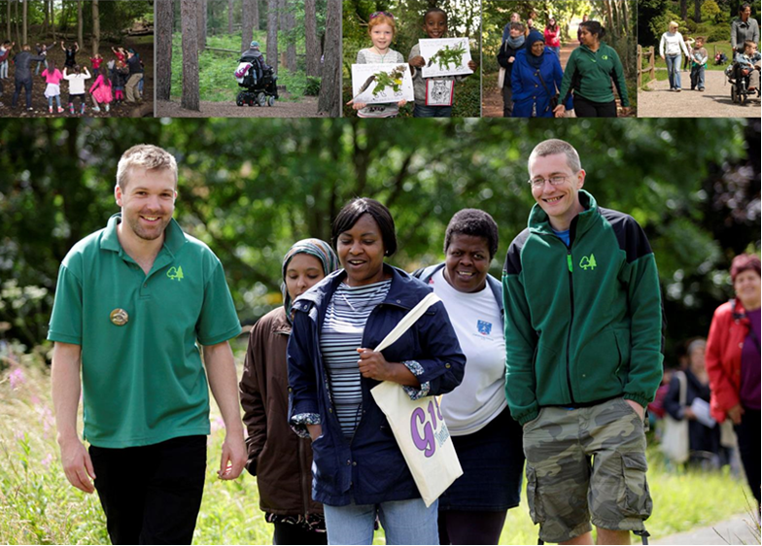
Contents

- Introduction  - About the Forestry Commission  2.1 Our Structure  2.2 Our Values  2.3 Our People Strategy and Equality & Diversity Strategy  - Our Approach to Equality and Diversity  3.1 Our Approach to Engagement  3.2 Our Approach to Equality Analysis  3.3 Our Approach to our Customers  3.4 Our Forests in Your Home  3.5 Monitoring Our Visitor Numbers  - Our Employees  4.1 Building and Retaining a Diverse Workforce  4.2 Restructuring Our Business  4.3 Equality and Diversity Training  4.4 Equality and Diversity Staff Forum  4.5 Staff Survey 2015  5. Equality Monitoring Data  5.1 Overview of our Analysis  5.2 Employees in Post  5.3 Full/Part Time Split at 31/3/16 | 5.4 Type of Contract at 31/3/16  5.5 Pay Band at 31/3/16  5.6 Internal Recruitment During 2015/16  5.7 External Recruitment During 2015/16  5.8 Performance Marking for year ending 31/3/16  5.9 Internal Training, Average Events Attended per Person During 2015/16  5.10 External Training, Average Events Attended per Person During 2015/16  5.11 Leavers During 2015/16  5.12 Disciplinary Action During 2015/16  5.13 Grievances Raised during 2015/16  5.14 Work Patterns at 31/03/16  5.15 Return to Work Following Maternity Leave  6. Equal Pay – including Gender Pay Gap Information  6.1 Equal Pay Audit  6.2 Average Earnings at 1st October 2016  7. Our approach to Monitoring and Evaluation  8. Conclusion and Further Information

1. Introduction
The Equality Monitoring Report 2015/16 has been developed to provide detailed information on the composition of the Forestry Commission workforce. It also helps demonstrate compliance with the Equality Act 2010 (Specific Duties) Regulations 2011 by providing information on the work taking place across the organisation that helps eliminate unlawful discrimination, advance equality of opportunity and foster good relations between different groups.

This will be the last Equality Monitoring Report which will report on our employees in England, Scotland and Forest Research as one staff group. Responsibility for Equality, Diversity and Inclusion was devolved to component parts of the organisation in April 2016. As such it is anticipated that separate reports will be published for England, Scotland and Forest Research from April 2018 in order to fulfil the distinct requirements set out by the Westminster and Scottish Governments.

2. About the Forestry Commission
The Forestry Commission is the Government Department responsible for the protection and expansion of Scotland and England’s forests and woodlands, including increasing their value to society and the environment.

The Forestry Commission is committed to ensuring that the forests and woodlands we manage are accessible to and enjoyed by all communities. We continue to identify and remove barriers to the enjoyment of our forests, woodlands and services that groups may encounter due to their protected characteristics (age, disability, gender reassignment, marriage and civil partnership, pregnancy and maternity, race, religion or belief, sex and sexual orientation).

The Forestry Commission:
- Welcomes millions of visitors every year to our forests and woodlands, many of whom utilise and enjoy our visitor centres and thousands of way-marked walks and trails, cycle routes and bridle paths, including accessible trails;
- Employs 2574 people (as at 31 March 2016);
- Plants many millions of trees every year;
- Sustainably harvests almost four million tonnes of timber every year, which equates to almost a third of the UK’s total domestic timber production;
- Is custodian of sustainably managed woods and forests and other land, two thirds of which lie within National Parks, Areas of Outstanding Natural Beauty or Sites of Special Scientific Interest;
- Takes degraded land no one else wants and turns it into green space for the benefit of all, helping to regenerate blighted industrial landscapes such as former coalfield communities and bring new woodlands closer to urban areas;
- Provides grants, licences and advice to community and private woodland owners to encourage new tree planting and sustainable forest management;
- Provides research services relevant to UK and international forestry interests, providing an evidence base for UK forest practices and UK Government policies.

2.1 Our Structure
The Forestry Commission has a unique structure. It is a statutory body and non-Ministerial Government Department with responsibility for forestry in England and Scotland. Under the Devolution Settlement, the Forestry Commission was designated a cross-border public authority. Therefore, it exercises its powers and duties separately and receives separate funding in England and Scotland.

The Forestry Commission has a statutorily appointed Board of Commissioners consisting of a Chair and up to ten other Forestry Commissioners, who are appointed by Her Majesty the Queen on the recommendation of Ministers. Delivery of policy, as well as progress against strategy objectives, is overseen in each country by the Commission's National Committees. The Forestry Commission is led by a Director in England and Head of Forestry Commission Scotland, who are also members of the Board of Commissioners.

The Forestry Commission takes the lead, on behalf of the Westminster and Scottish Governments, in the development and promotion of sustainable forest management and delivers the distinct forestry policies of England and Scotland through specific objectives drawn from the country forestry strategies.

There are three executive agencies that work to targets set by Commissioners and Ministers. Forest Enterprise England and Forest Enterprise Scotland manage our national forest estate, woodlands and other land in England and Scotland respectively on behalf of Government Ministers. Forest Research provides research services relevant to UK and international forestry interests and informs and supports forestry’s contribution to UK Governmental policies. Forest Research provides the evidence base for UK forestry practices.

Further information on the Forestry Commission, including its aims and structure, can be found on our website.

2.2 Our Values
The Forestry Commission is an organisation that values:

- Teamwork - We work collaboratively with each other and our stakeholders, ensuring trees, woods and forests meet the needs of society;
- Professionalism - We enjoy and take pride in our work, acting with integrity and political impartiality to achieve high standards of health and safety, quality, efficiency and sustainability;
- Respect – We value each other and our stakeholders, recognising diverse perspectives and treating everyone with consideration;
- Communication - We are open, honest and objective with each other and our stakeholders. We are prepared to challenge and to be challenged;
- Learning – We are always learning, developing the skills, knowledge and behaviours to support organisational success; and,
- Creativity - We seek new ways of doing things, sharing ideas and embracing change.

2.3 Our People Strategy and Equality and Diversity Strategy

The corporate plans for each country and for Forest Research determine the key strategic drivers for how the organisation manages its people and services.

During the period for which we are reporting, April 2015-March 2016, the People Strategy (2011-2016) ‘Fit for our Future’, focused on supporting staff to ensure that they were prepared, equipped and engaged to manage change in a positive and successful way. The new People Strategy (2016-2019), ‘Fit for our Future’, has the same vision and themes, one of which is Equality and Diversity, where we set out our commitments to:

- Legal compliance;
- Improving the diversity of our workforce; and,
- Supporting our staff in engagement with communities to meet the General and Specific Duties placed on public bodies through the Equality Act 2010.

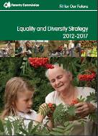
Our Equality and Diversity Strategy was published in April 2012. This is our framework to help embed the diversity elements of our People Strategy throughout the Forestry Commission until 2017. The vision of the Equality and Diversity Strategy is to have a diverse workforce that reflects the society that we serve and to continue to offer exemplar customer services to diverse communities.

The five goals of this Strategy are to ensure that we;

- Build on our successes and continue to work towards making our services and facilities available to all;
- Continue to ensure our departmental policies, organisational objectives and operational practices enable everyone to access our services and facilities;
- Continue to engage with communities to ensure our services and facilities are fit for purpose and tailored to meet their requirements;
- Continue to respect, support and value all our staff, treating them in accordance with our values; and,
- Recruit and employ people in order to make our workforce more representative of the populations in England and Scotland.

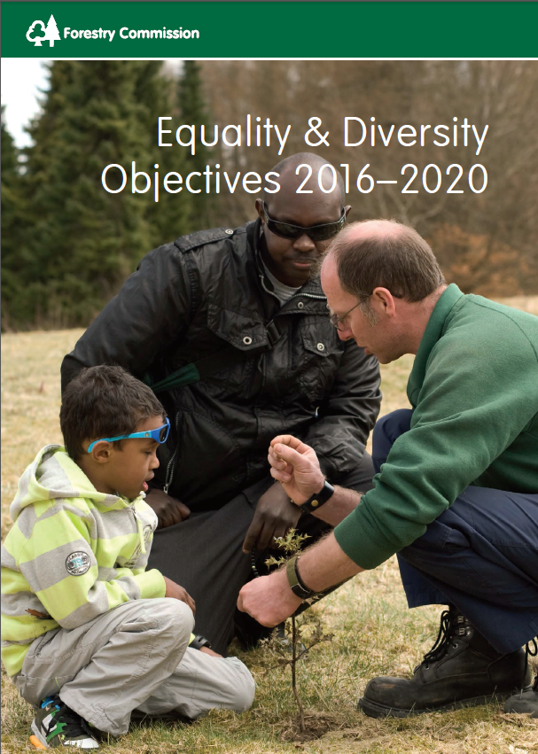
2.4 Our Diversity Objectives

In addition to the objectives set out in the People Strategy and the Diversity Strategy, we also produced a series of Diversity Objectives for the four years from 2012 to 2016. A new set of objectives for the Forestry Commission was published in April 2016, with separate objectives for England and Scotland covering the period 2016 – 2020.

The Objectives have been selected to ensure that the Forestry Commission meets the three aims of the General Duty as outlined in the Equality Act. The three aims of the General Duty are:

- To eliminate discrimination, harassment and victimisation;
- To advance equality of opportunity between people from different groups; and,
- To foster good relations between people from different groups.

We have classified the Objectives by each of the nine protected characteristics, and then split them between staff and customer focussed actions.

The Forestry Commission recognises that the diversity of its staff group is intrinsically linked to the provision of valued services to diverse communities and vice versa. Diverse staff can provide insight into ways of working with diverse communities and suggesting an inclusive approach to customer service. They act as role models and can encourage a wider pool of potential applicants to apply to work for the Forestry Commission if they can see that the organisation takes a positive and proactive approach to equality and diversity.

The Forestry Commission Equality and Diversity Objectives can be found on our website.

3. Our Approach to Equality and Diversity

Although forestry is a devolved issue, until April 2016 the Forestry Commission adopted a cross border and shared approach to equality and diversity. Responsibility for the implementation of the equality duties, as defined by the Westminster Government, was shared across the Forestry Commission, with guidance and support being provided from a central Diversity Team based in Edinburgh. This approach changed however, in April 2016, with responsibility for equality and diversity devolved to FC England, FC Scotland and Forest Research and will be reported on in next year’s Annual Equality Monitoring Report.

In developing this Annual Equality Monitoring Report, we recognise that the Forestry Commission has made progress in embedding equality and diversity into everyday business. However, we are not complacent and recognise that there is still much to achieve.

We have examined our relevant policies, functions, service planning and service delivery processes to ensure that no-one is in any way discriminated against or subject to unfair opportunity/adverse treatment. Further, as an employer we ensure that appropriate training is available to all staff to raise awareness of the equality and diversity agenda and ensure that employees are aware of their responsibilities. We have been reviewing this approach since devolution of equality and diversity and will be developing new programmes of activity relevant to each part of the organisation. This will be reported on our website in due course.

As a service provider, the Forestry Commission takes an inclusive approach to working with individuals and organisations. We also procure goods and services from organisations and individuals that have or subscribe to equality and diversity values and objectives, as set down in legislation.

3.1 Our Approach to Engagement
As a Government Department we comply with the current guidance on consultation and engagement. Therefore, consultations are conducted with key stakeholders when regulations change.

The provision of recreation is one of our principal objectives and we understand that recreation initiatives provide us with a major opportunity to meet the General Duties of the Equality Act, particularly around advancing equality of opportunity and fostering good relations between different groups. In our internal recreation guidance, we stress the importance and value of understanding the local community and being proactive in identifying and seeking views from those people who currently do not access our services, as well as those we are more used to working with and who are established visitors to our forests. The guidance includes checklists to assist field practitioners to include their whole community. Through engagement we hope to improve our understanding of any barriers to visiting our forests and to work with different groups to identify and put in place solutions, events and facilities that will encourage more frequent visits from a more diverse range of the local and wider population.

Case Study: Wild in the Woods

Wild in the Woods was an outdoor creative arts project designed to encourage creative engagement with nature, inspire a love of trees and the great outdoors and instil a sense of ownership and stewardship of local woodlands. Sessions took place between July and October 2015 and were held in Hermitage of Braid Nature Reserve in Edinburgh. The participants were a multi-cultural, multi-generational group of 31 local children aged between two and eleven years old, along with their parents and carers.

The project contact and delivery was based on Forest School Holistic Learning Principles, also in accordance with the Scottish Government’s Education programme, Curriculum for Excellence.

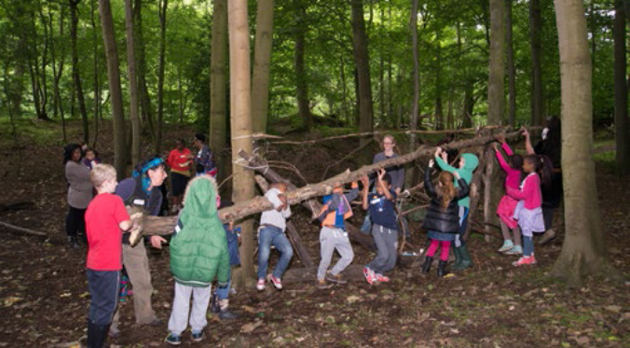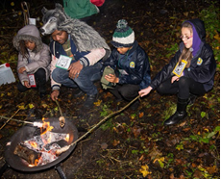

The project had a woodland animal theme and involved participants learning various bush skills and participating in physical and creative activities through meeting six “animal guides”. All the animal guides were Scottish native animals that are protected, endangered or even extinct. Each week a different animal set the theme for the day and guided the group through a series of activities. Through focussing on behavioural traits common to both humans and the specific animal of the day the team were able to encourage and inspire participants to work on similar characteristics in themselves and within the group. For example:

• Caledonian Bear - being strong and protective, feeling safe & cared for
• Grey Wolf – Sociability, teamwork, loyalty, friendship
• Red Squirrel – Agility, quick thinking, planning ahead, being prepared
• Scottish Wild Cat - Courage, focus and self-reliance
• Golden Eagle – Vision, aspirations, hopes and dreams

This creative approach captured the participant’s imagination inspiring them to respect and celebrate trees and the ecosystems that surround them while encouraging them to work as a team and to be more healthy, active, imaginative, self-confident and self-reliant. Designed as an antidote to a sedentary lifestyle Wild in the Woods included lots of opportunities for children and adults to come alive; running and playing in the woodlands, getting in touch with their physicality and their “wild sides” within a secure and focused environment. Evaluation was very positive both from children and their parents/carers.

Case Study: Involving the Diverse Community at Savernake

Savernake is a large and diverse forest which is a Site of Specific Scientific Interest and lies partly within the North Wessex Downs Area of Outstanding Natural Beauty.

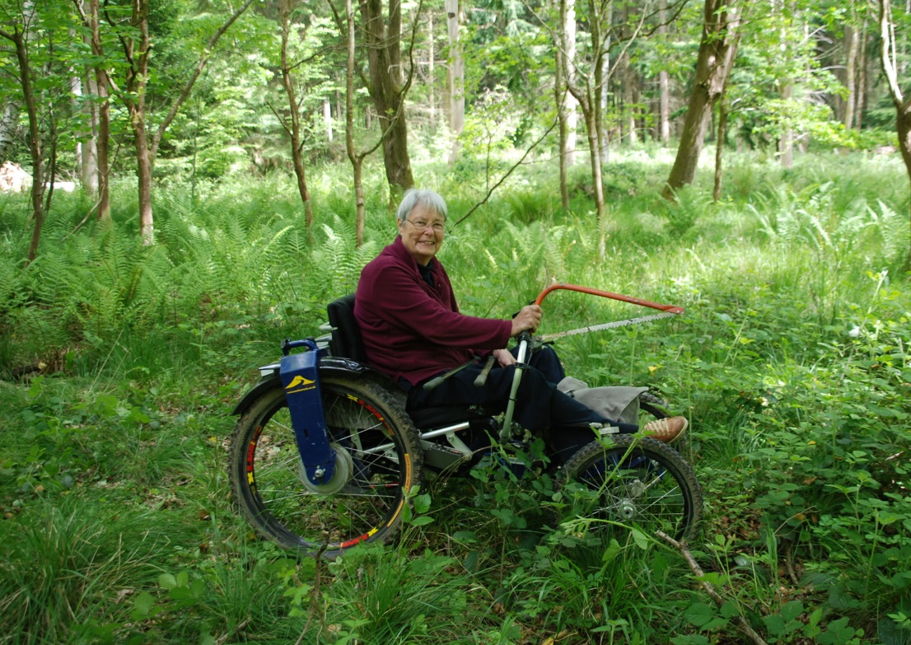
Nikki Morgans, Recreation and Community Ranger is passionate about ensuring that the local community feel involved. Nikki and the team reached out to the local community and have over the past 18 months been working with a diverse range of volunteers and the Richmond Fellowship. The Fellowship is an organisation set up to champion the recovery and social inclusion for those with mental health difficulties. This volunteering work is important as it has created the feeling of community involvement, the volunteers can see what the Forestry Commission are doing and they have also learnt some new skills through the training provided. Nikki explains that “she’s pleased that we can offer something for everyone – the site is very accessible and there is meaningful, interesting work for all kinds of people to enjoy”. More information on Savernake can be found at http://www.forestry.gov.uk/savernake.

3.2 Our Approach to Equality Analysis
We have continued to mainstream the use of Equality Analysis (EqA), to ensure that our new policies or services, and any changes to existing policies or services, fully take into account any impact on our diverse customers and staff.

Our HR policies, including Learning and Development strategies and initiatives, are subject to EqA, as well as our customer-facing projects.

The approach to Equality Analysis was reviewed in late 2016 and new guidance on equality impact assessments is now in place (January 2017). However, Equality Analysis was the model used during the period covered by this report.

3.3 Our Approach to our Customers
The Forestry Commission recognises that forests and woods contribute positively by providing opportunities for people to participate in and enjoy woodlands. We deliver an extensive range of practical programmes to ensure that communities and individuals can get the most from them.

There are a number of ways in which we can reach and engage with people. For example, we offer:

- Education and learning initiatives;
- Healthy living initiatives and activities;
- Play, recreation and sporting opportunities;
- Volunteering; and,
- Community forestry and woodland creation in and around towns and cities, to be closer to where people live.

As the needs of communities change and develop, we will continue to adapt to ensure that we offer equality of opportunity for all.

We proactively promote our services and facilities to anyone who wishes to use them. However, we also recognise that there may be perceived barriers and reasons why people may not be able to fully benefit from our facilities. Therefore, we are actively seeking to address this by adapting infrastructure, providing a wide range of activities and events, engaging with communities and in some cases providing specialist equipment and/or tailored activities. To achieve our objectives, the Forestry Commission is working closely with a range of partner organisations at a local, regional and/or national level.

We undertake a range of surveys to compare and test customer satisfaction and explore needs. These range from public opinion surveys, site questionnaires, focus groups, to feedback forms. Our site managers use local demographic data to more strategically assess the potential demand for services and facilities and compare this with actual site usage. Our external websites are built to level AA of the Web Content Accessibility Guidelines standard, to meet the demands of a wide range of users, including those with visual impairments, deafness and hearing loss, learning disabilities, cognitive limitations, limited movement, speech disabilities, photosensitivity and combinations of these. Applying this standard ensures that we are inclusive in how we provide information to all potential customers, suppliers and the public to meet our public duties around accessibility; and that our websites are also more accessible to users in general. More information on the accessibility of our website can be found here.

Case Study: Moors Valley wins Gold Access and Inclusivity Award

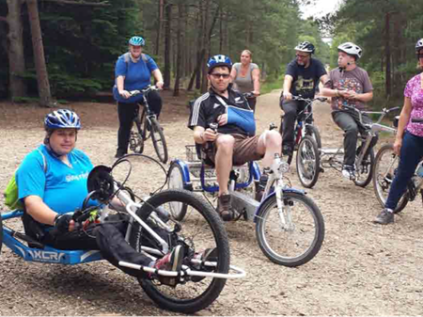
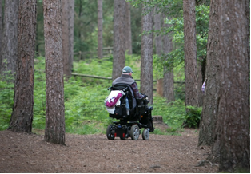
Moors Valley Country Park and Forest is a joint venture between East Dorset District Council and the Forestry Commission. Moors Valley is passionate about ensuring that they provide countryside recreation of the highest standard for people of all ages and abilities and for people to improve their physical and mental wellbeing. The work that the team has put in place has been recognised with a Gold Access and Inclusivity Award by the Dorset Tourism Awards.

This award recognises organisations that excel in being accessible and inclusive and can demonstrate exceptional customer service to all, particularly those with impairments and other access needs i.e. mobility, auditory, sensory or dietary.

Moors Valley is one of the first country parks to install a Changing Places toilet, and remain at the forefront of organisations providing access to the countryside for people with limited mobility through activities such as free, guided accessible cycle rides and wheelchair-friendly tractor and trailer rides. We have introduced a designated Accessibility Champion in partnership with East Dorset District Council to lead on identifying and helping remove barriers to participation as well as raising awareness of staff and on-site businesses to the need to consider access and inclusivity in all their work. In March 2016, Moors Valley introduced their first audio trail styled as “Ranger in your Pocket” which is a short audio tour taking visitors on a journey around Moors Lake providing wildlife information from a Ranger without the need to attend a guided walk event. The trail’s audio files can be downloaded from the website to visitor’s smart phones or mp3 players.
During 2015, we worked with a local community group, New Forest Access for all to remove cambers and improve footpath gradients and surfacing around benches along the route. Over the latter half of 2015, we extended our fleet of accessible bikes to enable more individuals to take part on our free guided rides. Accessibility is really at the heart of what Moors Valley is about and they are constantly striving to do more and more. More information on Moors Valley can be found at http://www.forestry.gov.uk/moorsvalleycountrypark

Case Study: Inspire Network Takes a Pledge on International Women’s Day
The Inspire Network aims to create an inclusive working environment through informing, empowering and connecting our staff. It achieves this by organising a monthly programme of events covering topics such as achieving a healthy work-life balance, wellbeing in the workplace, and career development.

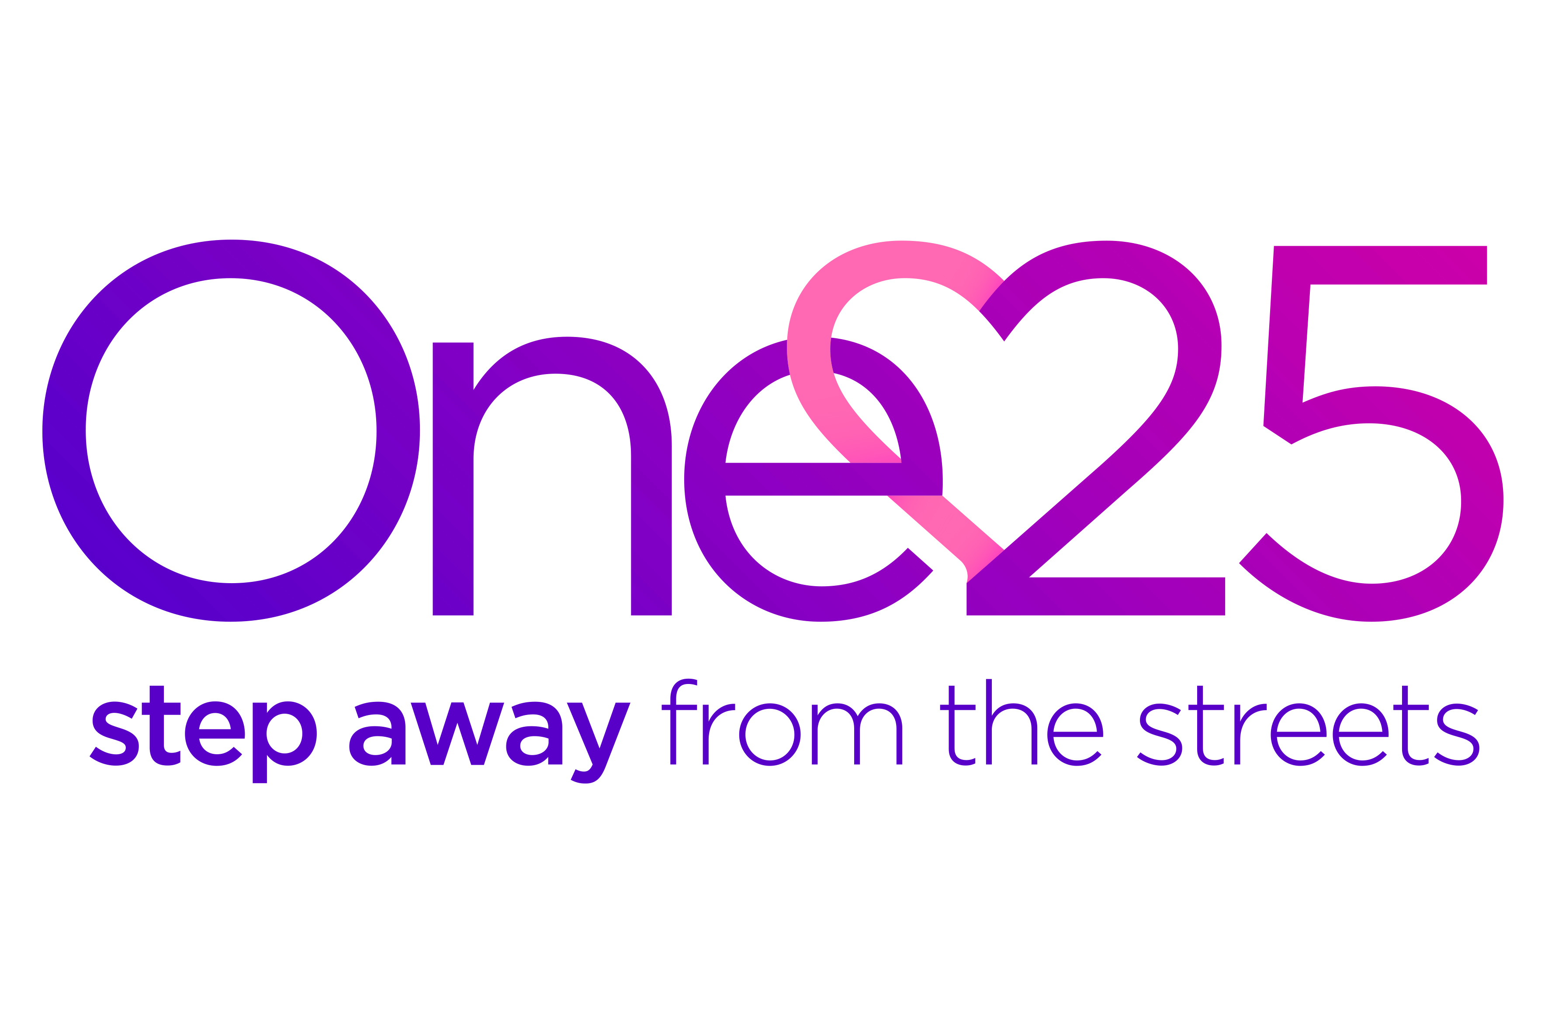
On Tuesday 8th March 2016, the Inspire Network organised some activities to celebrate International Women’s Day, the global theme for 2016 was taking a pledge for parity. The Inspire Network chose to take a pledge to support a local charity who’s vision is to create a community where all women are valued and able to live fulfilled lives without the risk of being trapped in sex-work. The interactive talk by the charity told us how they are reaching out to women trapped in or vulnerable to street sex-work, supporting them to break free to build new lives away from violence, poverty and addiction. The empowering talk was heart breaking at times realising how women are struggling in our city. One 25 are really making a difference in the local community and because of them, last year 59 of the 147 women who were street sex-working were able to break free.

The Forestry Commission’s National Office really got behind supporting the charity and raised £694 in 2016 to help them achieve their vision. Staff also helped raise awareness amongst colleagues of the issues faced by the women who are supported by the charity. Further information on One25 is available at http://one25.org.uk/

Case Study: Volunteer Community Champions Programme

The Volunteer Community Champions programme launched in April 2015. The woodland programme is designed to train up to 12 community volunteer champions per year to engage with community groups in Central Scotland, helping to challenge and break down barriers in accessing local woodlands.

The programme provides specialist training for volunteers along with a £1,000 budget to deliver four sessions for communities from socially diverse backgrounds through outdoor recreation, learning, health and wellbeing. The programme was launched in partnership with CEMVO Scotland and over the first year, 11 Volunteer Community Champions successfully complete their training and delivered 37 sessions engaging with 734 people from across the protected characteristics.

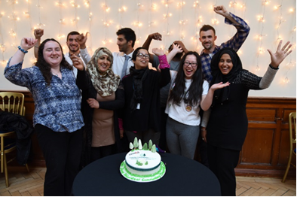
Specialist training provided includes Outdoor First Aid, Environmental Awareness, Bushcraft Skills and John Muir Award Leader training. Volunteer Community Champions also receive additional support to help them work through the funding application process.

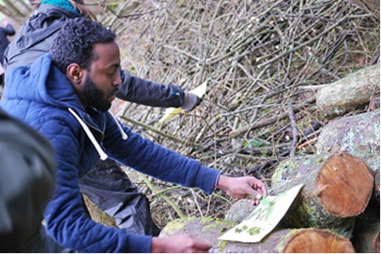
It was announced in February 2016 that the programme would continue in 2016/17. Further information on the Volunteer Community Champions is available from our Central Scotland Conservancy office.

3.4 Our Forests in Your Home
In order to give people who are unable to visit, or are unsure of visiting our forests a taste of what we can offer, we have created pages on our web site called Our Forests in Your Home. The site shows many of the activities that can be experienced by visitors, gives information and videos on wildlife, recreation options and climate change. The site also offers a link to the pages that let
people search for details of the nearest forest to their home and discover what events and facilities are available there. In order to make these pages as useful and interesting as possible for our intended audience, we will add to them and refine them over time as new content becomes available.

3.5 Monitoring Our Visitor Numbers
During 2015 we conducted Public Opinion Surveys for Scotland and England. The Surveys indicate that people have a great interest in visiting forests and that around two thirds or more of all respondents said they had visited forests or woodlands in the last few years.

The Public Opinion Survey records positive responses from respondents in different categories. Those that responded “Yes” to the question ‘In the last few years, have you visited forests or woodlands for walks, picnics or other recreation?’ also provided the
following information in relation to their protected characteristics:

Disabled | Not disabled | Female | Male | BAME | White | Age 44 or less | Age 45 or over
6617% | 83% | 51% | 49%19 | 6% | 94% | 46%69 | 54%11

We are increasingly creating woodlands close to towns, to make these green spaces more accessible to a wider range of communities and customers. Those that responded “Yes” to the question ‘Types of woodlands visited - Woodlands in and around towns.’ also
provided the following information in relation to their protected characteristics:

Disabled | Not disabled |  | Female | Male |  | BAME | White |  | Age 44 or less | Age 45 or over
20% | 80% |  | 48% | 52% |  | 9% | 91% |  | 54% | 46%

Those that responded “Yes” to the question ‘Types of woodlands visited – Woodlands in the countryside’ also provided the following information in relation to their protected characteristics:

Disabled | Not disabled |  | Female | Male |  | BAME | White |  | Age 44 or less | Age 45 or over
18% | 82% |  | 48% | 52% |  | 2% | 98% |  | 45% | 55%

The Public Opinion Survey is undertaken every two years. This year we have few significant changes. However, there was an
increase from 2% to 7% in the number of BAME visitors to sites near towns or cities, although no increase in the number of BAME visitors to sites in the countryside.

The responses given by participants of the Public Opinion Survey highlighted that there are various reasons why people do not visit forests. These reasons include personal mobility problems (difficulty in walking, etc), not having a car or that woods were too far away.

Our initiative of creating and facilitating the creation of woods close to towns should, over time, mean that more people have access to woodlands that are closer to where they work and/or live. We also continually review our existing facilities to ensure they are available and can be accessed by as wide a range of people as possible. To ensure that these facilities meet the needs, where
possible, of all our diverse customer groups, we continue to work to understand the barriers which can prevent people visiting our forests and are working with different groups and associations to identify and put in place solutions, and promote the services we
offer.

4. Our Employees

4.1 Building and Retaining a Diverse Workforce

We want to develop a diverse workforce that reflects the communities we serve, and this is a key theme within our People Strategy. The introduction of Government wide reductions and restrictions on budgets has meant that our external recruitment has reduced, due to the requirement to downsize the organisation and the wider public sector. Improving the diversity of our staff is difficult under these continuing restrictions, but it remains an aim.

Traditionally, employment in forestry has been male dominated and perceived as a practical, outdoors, and physical role. In order to attract a more diverse range of applicants to our advertised vacancies we have been proactive in trying to dispel some of the myths surrounding forestry, including working with schools and careers services to promote the forestry sector as a career option, developing skills training in a forest environment for young people aged 16 to 24.

Some examples of the jobs in forestry include the development of policy, the management of grants and regulations, sales and retail, public education, recreation, conservation, teaching and lifelong learning, resource planning, development planning, science and research, civil engineering, partnership brokerage, Human Resources, finance, marketing, communications and business development.

4.2 Restructuring Our Business
As a Government Department, the Forestry Commission will continue to embed the structural changes necessary as a result of the Government’s Spending Review reductions.

In addition to this, the Government’s response to the Independent Panel on Forestry included the possibility of establishing in the longer term of a new body to hold the Public Forest Estate in trust for the nation. In the shorter term, Forest Enterprise is developing greater autonomy and more freedom to manage its own resources and direction within the Forestry Commission governance change programme which also includes the Scottish Government proposal to take full responsibility for forestry in Scotland and in the autumn of 2016 held a public consultation on the future of forestry in Scotland.

As a result of these changes, there is an ongoing programme of work to establish new corporate services in FC England, FC Scotland and Forest Research, moving away from the hybrid shared services model. As such and since April 2016 there has been bespoke equality, diversity and inclusion support for the countries and Forest Research.

4.3 Equality and Diversity Training
The Forestry Commission has developed and delivers in-house equality and diversity training. We have different levels of training events, tailored to suit the needs of staff and depending upon their level of exposure to customers and/or their involvement in policy making. The training includes all aspects of equality and relates to the Forestry Commission’s business. We have developed on-line training modules for staff and managers and face-to-face training on the Equality Analysis process. The sessions included in our New Entrant (induction) courses have also been re-designed. In addition, FC employees now have access to the suite of Equality and Diversity training available through Civil Service Learning.

All new and existing training events managed by the Forestry Commission are reviewed to ensure appropriate equality and diversity messages and considerations are included. All our in-house Learning and Development trainers have attended learning sessions and have regular liaison with the Equality, Diversity and Inclusion Managers to increase their understanding of equality and diversity and how it might impact upon their work. Over the 2015/16 period, the Diversity Team presented sessions on the future of the Diversity agenda, the business benefits of engaging with diverse communities and having diverse staff and unconscious bias to the entire Learning and Development team at one of their bi-annual team away-days.

4.4 Equality and Diversity Staff Forum
Formed in 2008, the Staff Forum meets on a regular basis to provide advice and feedback on policies and services that affect staff, to highlight any equality and diversity issues and support the Equality and Diversity Team in promoting equality and diversity throughout the organisation.

Over its last 12 months the Staff Forum contributed to a number of policy developments and reviews, including:

- Engaging with our Diversity Champions to continue to embed diversity priorities across the organisation;
- Reported on diversity events in their business area, and shared best practice with others; and,
- Contributed to the review and refresh of HR and Equality and Diversity policies, processes and guidance notes that impact on staff.
- Helped develop and cascaded a practical language guide, reinforcing acceptable language in order to create an inclusive and welcoming workplace.

The Forum met for the last time in February 2016, pending devolution of equality, diversity and inclusion functions to the component parts of the organisation. New arrangements are now in place and will be reported on in next year’s reports.


4.5 Staff Survey 2015
We conduct a staff survey every two years to gauge satisfaction levels across the organisation and to identify areas for further investigation and improvement. The latest staff survey was undertaken in September 2015.

Overall, 62% (1605) of staff in post completed the survey, which is higher than the response rate of the previous survey in 2013. This means the FC has a good robust set of results on which to make decisions and inform the development and implementation of the People Strategy for the future. The organisational strengths and improvements since 2013 all contribute to a continued high level of staff engagement with the index at 71% in 2015 which is 13 percentage points higher than the benchmark for other civil service organisations.

The staff survey asks staff to provide information on their protected characteristics, which enables us to gather and analyse data in relation to information not currently gathered on our HR system, including religion and belief, sexual orientation, and gender identity, as well as age, disability, ethnicity and gender.

Of those staff that completed the staff survey:

- 57% said they were male (down 1% from 2013), 32% female (same as 2013) and 11% preferred not to say (up 1% from 2013).

- 2% identified as being aged 16 to 24 (down 1%), 15% as 25 to 34 (down 1%), 23% as 35 to 44 (same as 2013), 31% as 45 to 54 (up 1%), 20% as 55 to 64 (up 4%) and 1% as 65 and over (same as 2013) and 9% preferred not to disclose their age (down 3%). Note that because of rounding figures, these percentages do not add up to 100%.

- 92% identified as White (down 2% from 2013), 2% identify as Black Asian or Minority Ethnic (up from 2013) and 6% preferred not to disclose their ethnicity (same as 2013).

- 40% identified as Christian (all denominations, down 2%), 46% as having no religion or as Atheist (up 3%), 2% as other religion (down 1%), and 12% preferred not to disclose their religion or belief (same as 2013).

- 86% do not have a disability, 5% considered themselves to be disabled (up 1%) and 9% preferred not to disclose.

- 82% identified their sexual orientation as heterosexual (down 3% from 2013), 2% as a gay man or lesbian or as bisexual (up 1% from 2013) and 16% preferred not to disclose their sexual orientation (up 2% from 2013).

- 3% identified as being transgender (up 1.5% from 2013).

An interesting observation is that we now have a similar number of staff from the following protected characteristics; BAME, LGB and other religions, which helps FC managers realise the importance of a broad diversity agenda, supporting an inclusive workplace for all staff from all protected characteristics.

More employees would rather not share their sexual orientation, than any other protected characteristic, with 16% withholding the information, whereas only 6% withheld their race, 12% their religion and 9% their disability. Also, a surprisingly high number of people failed to identify their gender (11%). One of the country Diversity & Inclusion Managers is on the people survey working group for the next people survey in 2017. One aspect this working group will be focusing on is ensuring the communications emphasise to staff the anonymity of participating in the survey and particularly sharing their diversity information with us.

Under the section on “Inclusive and Fair Treatment”, the following results were received:

- “My part of the organisation has a culture where discriminatory treatment, harassment and bullying are not tolerated”. Average positive score was 79% (a fall of 3% since 2013) and 8% disagreed.

  - There was little difference in ages, although among 16-24 year olds, 79% agreed, while 83% of over 55s agreed with it. Similarly, 9% of 16-24 year olds disagreed with the statement, while 7% 45-54s, and 6% of over 55s disagreed.
  - 81% of men said bullying was not tolerated, against 82% of women.
  - 78% of staff who told us they consider themselves to have a disability, agreed with the statement, compared to 82% of staff without a disability.
  - While 81% of Christians and Atheists agreed that discrimination was not tolerated, a lower proportion of other religions felt this, with only 69% agreeing.
  - 79% of LGB staff said they agreed with the statement, and 82% of heterosexual people. However, while only 7% of heterosexual people disagreed, 12% of LGB people disagreed that discriminatory treatment, harassment and bullying were not tolerated.

- “I would feel able to report bullying/harassment without worrying that it would have a negative impact on me”. 72% of participants provided a positive response (down 4% on 2013), while the negative response was 11%.

  - In terms of age, 78% of over 55s and 75% of 16-24s agreed. While 35-44 and 45-54 year olds were both lower at 72%.
  - On gender, males were more likely to agree they’d feel comfortable reporting bad behaviour (76%); women were lower at 70%. Similarly only 9% of men disagreed, but 12% of women would not be comfortable reporting bullying, marking a strong gender difference.
  - 58% of respondents who consider themselves to have a disability agreed with this statement, while 75% of those without a disability agreed. Also, 10% of people without a disability disagreed that they would be able to report bullying without worrying about any negative impact.22% of people who have a disability would not report it.
  - On race, 78% of BAME were positive about reporting problems without any impact on them, against 72% of the white majority. Although 15% of BAME disagreed that they wouldn’t worry about reporting, whereas only 12% of White respondents did.
  - In terms of religious groups, 73% of Christians and 74% of Atheists were comfortable reporting concerns, whereas only 69% of other Religions felt comfortable about the lack of impact. There was no difference in negative perceptions; all groups said 11% would not report it.
  - Heterosexual (74%) and LGB (73%) reported similar levels of feeling able to report without an impact.
- “I am treated fairly at work”. 82% of participants provided a positive response, down from 85% in 2013, while 16% responded negatively that they weren’t.

  - Men and women responded the same positive rate with 85% agreeing, and 6% disagreeing. There was little difference in terms of age with all groups responding 85% positive apart from 45-54 who were at 82%.
  - Disabled people were less positive (78%) than those without a disability (85%). 12% of those with a disability responded that they disagreed about being treated fairly, compared to 6% of those without.
  - BAME were less likely to feel respected, 74% compared to 84% of White staff; although the same amount of staff disagreed, 7% for both groups.
  - LGB staff responded only slightly less positively than heterosexual staff, 82% versus 84%, although two years ago, this figure was 100% for LGB staff.

- “I am treated with respect by the people I work with.” 84% of participants provided a positive response, a decrease of 1% from 2013, while 7% disagreed.

  - There were no significant age differences, although age 45-54 again were less positive (82%) than others. 2% more women felt treated with respect compared to men, (87% compared to 85%) and men were slightly more likely to disagree they were treated with respect.
  - Disabled staff felt less positive, only 78% against 86% non-disabled. There were no significant racial differences in terms of positive responses to being treated with respect (White respondents 84% and BAME 85%)
  - Other religious groups were likely to feel less respected, (only 78% agreed compared to 86% Christian and 85% Atheists, and were more likely to say they were not treated with respect 11% against 6% for all others.
  - LGB staff (88%) felt slightly more respected than heterosexual staff (86%).

- “I think my part of the organisation respects individual differences e.g. cultures, working styles, backgrounds, ideas, etc.” 82% of participants provided a positive response, (same as in 2013) and only 5% disagreed.

- Women were more positive about their teams respecting differences (86%) than men (83%). Disabled people were less likely to agree 79% against 84% non-disabled and much more likely to disagree, with 4% against 13% non-disabled. Only 2% less BAME staff agreed (81% versus 83% white) but 11% disagreed, compared to 5% White staff. Other religions were less positive and more likely to disagree (8%) about their teams respecting differences, compared to Christians (5%) and Atheists (4%). LGB Staff felt their teams were positive (88%), compared to 84% heterosexual staff.
The staff survey also seeks to identify where staff feel they are being bullied or harassed, or that they feel they are being discriminated against. The following results highlight that in response to the questions:

- “Are you currently being harassed or bullied at work” 2% of participants stated yes, a decrease of 3% from 2013; and,

- “During the past 12 months have you personally experienced discrimination at work?” 5% of participants stated yes, a decrease of 1% from 2013.

The highest age group to feel this were the 45-54 year olds at 3%. There were no gender differences. 7% of disabled staff felt they were being bullied or harassed. BAME staff reported that they feel less likely than white employees to experience bullying and Other Religions a little more than Christians and Atheists. However LGB employees are three times more likely to feel bullied than heterosexual employees (6% compared 2%).

Based on investigation and analysis, it seems increasingly unlikely to be accurate that 3% of employees who answered the survey have transitioned gender. This equates to 49 individual employees who have transitioned in their lifetime. An estimate of the GB Trans population is 1%, with approximately 20% of this group seeking treatment. This means that according to the Staff Survey results the FC has considerably more transgender people than the average UK population. This seems unlikely and the higher reporting rate is likely to be mis-reporting.

The results show that there is a sizeable group of employees who are reluctant to share their personal demographic diversity data. This group of employees are among the more disengaged employees when answering every question. Equality, Diversity and Inclusion Managers will continue to explore the reasons for this; however initial research has found that other public authorities are encountering similar challenges in collating this information. Work continues to be done to raise awareness of bullying and harassment and how staff can raise concerns. The Forestry Commission has a zero tolerance to bullying and harassment.

5. Equality Monitoring Data

We have completed a detailed monitoring process for employment data collected between April 2015 and March 2016. In the outcomes detailed in the following tables, we have represented the total Forestry Commission figures. The information was based on a snapshot as of 31st March 2016.

Please note that staffing data used to complete these tables covers those considered to be in paid employment by the Forestry Commission, including Public Appointments, office holders, and some apprentices. As such, figures may differ from other published reports, which only include Forestry Commission employees.

5.1 Overview of Our Analysis

The following tables show the detail of our workforce and specific comments have been made against each table. In summary, the tables below demonstrate that our workforce is predominantly male (65%), White (99%), not disabled (97%) and aged 40 or over (70%).

In our internal recruitment and promotion process, female applicants were slightly more likely to be successful and promoted than their male colleagues. This marks a change from last year where men were more likely to be successful. The percentage of women applying for internal vacancies and promotions increased this year. No applicants with a disability were interviewed or successful. We shall continue to monitor this, but the low numbers of disabled employees make it difficult to draw conclusions. There were no direct reports of discrimination by people with disabilities based on the recruitment and/or promotion procedures. BAME applicants were slightly more likely than White applicants to be successful in comparison to the overall number of applications from this group. Again, we shall continue to monitor this, but the low numbers of BAME employees employed overall and applying for vacancies make it difficult to draw conclusions.

As a result of Government Spending Reviews, we have limited our advertising programme which promoted our job opportunities in media outlets specifically targeted to women, people with disabilities and people from minority ethnic backgrounds. We took this action, as although a more limited recruitment programme remained, we did not want to raise expectations beyond our capacity to recruit while the organisation was downsizing. However, our External Recruitment data shows that there was an increase in the number of applications from people from Black and Asian Minority Ethnic (BAME) communities, and those aged 40 and over this year. The numbers however remain low in comparison to the overall number of applications.

We provide a wide range of internal training, to suit the requirements of the business and provide a Management Development Programme to provide our managers with the necessary skills to progress, or to improve their performance. This programme is targeted more towards managers’ individual skill sets than our previous management training events. The Forestry Commission has its own in-house Learning and Development team, who design and deliver training in response to business needs. External training is also widely used to cover areas of particular expertise e.g. IT software. Our in-house Learning and Development team receives regular updates on equality and diversity issues and offers flexible training options to those who request them. This enables more people to access training by removing barriers created by the training materials or by the need to travel to a training venue or commit whole days to training.

Our analysis allows us to identify and investigate any apparent discrepancies in the year, but the low numbers of disabled and BAME employees means that the data can be significantly changed by just one or two people being promoted, accessing training, receiving top performance marks etc. We compare data gathered over the years to see whether any trends are developing and whether discrepancies are repeated year on year. There are some historical and cultural reasons behind the composition of our workforce. Careers in forestry operational roles can be perceived as masculine and requiring great physical strength and mobility; this has resulted in long-standing occupational segregation. There is work underway to change this perception and our employment brand.

5.2 Employees in Post

The following table provides information on the protected characteristics of our 2574 employees in post on 31st March 2016.

Employee Data |  | Disabled | Not disabled | Not disclosed |  | Female | Male |  | BAME | White | Not Disclosed |  | Age 39 or less | Age 40 or over
Percentage |  | 3% | 97% | <1% |  | 35% | 65% |  | 1% | 99% | <1% |  | 30% | 70%

The table shows that our workforce of 2574 people in March 2016, remains predominantly not disabled, male, white and aged 40 or over. Further analysis shows that only 3.7% (94) of our staff are aged 24 or under.

There were 26 fewer employees this year than the number reported last year. There is a slight increase in the number of employees declaring a disability and a 1% increase in numbers of female employees, but female employees make up only approximately 35% of the total workforce. There is also a 2% increase in the number of employees aged 40 years or older.

5.3 Full/part time split at 31 March 2016

All Staff |  | Disabled | Not disabled | Disability not disclosed | Female | Male | BAME | White | Ethnicity not disclosed | Age 39 or less | Age 40 or over
Full time | *84% | 3% | 97% | <1% | 28% | 72% | 1% | 99% | <1% | 33% | 67%
Part time | *16% | 4% | 95% | <1% | 72% | 28% | 1% | 98% | 1% | 23% | 77%
Not disclosed/  Anomalies | *0.4% | 22% | 78% | n/a | 22% | 78% | n/a | 100% | n/a | 11% | 89%
(* percentage of all staff)

Of the staff employed by the Forestry Commission on 31st March 2016, 2151 (84%) worked on a full time basis. 414 (16% of the total workforce) worked on a part time basis. Almost ¾ of employees working part time were women, whilst almost ¾ of employees working full time were men. Of the 414 employees working part time, 77.1% were aged 40 or over, whilst 67.3% of those working full time were in the 40+ age group. This is no surprise given that almost 70% of all employees are in this same age group.
The Forestry Commission has a range of family friendly policies in place to ensure that staff are supported and can work in different roles.

5.4 Type of contract at 31 March 2016

 | Disabled | Not disabled | Female | Male | BAME | White | Ethnicity Not disclosed | Age 39 or less | Age 40 or over
Perm | 72% | 89% | 85% | 90% | 83% | 89% | 43% | 80% | 92%
Fixed Term Temp | 9% | 4% | 6% | 4% | 8% | 5% | 50% | 10% | 2%
Short Term Temp | 15% | 4% | 6% | 4% | 8% | 4% | 7% | 8% | 3%
Other* | 4% | 3% | 3% | 2% | 1% | 1% | 0% | 2% | 3%
* Other – Casual, Office Holders, Part year appointments, Re-employed pensioners, seconded officers, fixed term recurring appointment, committee members, other contractors

The table highlights that the majority of the Forestry Commission’s staff are on permanent contracts. For example 72% of disabled employees have permanent contracts. As the organisation is currently undergoing a major change programme, there has however been an increase in recruitment of Fixed and Short Term staff.

In a similar pattern to that noted last year, there was an increase in the number of Short Term Temporary Assignments declaring a disability, with 15% of disabled employees on STTA contracts, where it was previously 11%. This could indicate that newer employees are more likely to declare a disability. This will be investigated further to determine any other reasons.

5.5 Pay Band at 31 March 2016

 | Disabled | Not disabled | Disability not disclosed | Female | Male | BAME | White | Ethnicity not disclosed | Age 39 or less | Age 40 or over
Senior Pay Bands* | 1% | 1% | 0% | <1% | <1% | - | - | - | <1% | <1%
Middle Pay Bands** | 5% | 12% | 0% | 11% | 13% | 17% | 7% | 8% | 4% | 15%
Other Pay Bands*** | 93% | 86% | 40% | 87% | 85% | 83% | 92% | 92% | 95% | 82%
Contractors and Office Holders | 1% | 1% | 60% | 2% | 2% | - | 1% | - | <1% | 2%
* Indicates staff who are Commissioners, or in pay-bands SSG1A, SSG1, and SSG2;** Indicates staff who are in pay bands PB1, PB2 and PB3; and *** Indicates staff who are in pay-bands PB4, PB5, PB5 (Op), PB6A, PB6A (Op), PB6B and PB7.

The table shows that distribution of protected characteristics across the pay bands is quite even and has not changed significantly from the figures reported in previous years, with non-disabled, male and aged over 40 staff likely to be in a higher pay band.

The differential for age at Middle Management level can be explained by longer service, with most senior staff being older. Despite continued staff turnover and because of limited permanent recruitment, there has been little change in the distribution of staff across the Pay Bands compared to previous years. The most significant difference is for disabled staff in the lower grades, where this year there was an increase of disabled people in the lower grades from 89% to 92.7%. This could as a result of greater disclosure on disability, but will be investigated further.

5.6 Internal Recruitment during 2015/2016

Internal Recruitment | Total | Disabled | Not disabled | Disability Unknown | Female | Male | Gender unknown | BAME | White | Race unknown | 39 or less | 40 or over | Age unknown
Number and percentage of applicants | 290 | 2% | 93% | 5% | 37% | 62% | 1% | 2% | 94% | 4% | 59% | 38% | 3%
Number and percentage of  Interviewed applicants | 91 | - | 92% | 8% | 37% | 62% | 1% | 2% | 95% | 3% | 54% | 41% | 5%
Number and percentage of  Successful applicants | 71 | - | 97% | 3% | 39% | 60% | 1% | 3% | 92% | 5% | 63% | 34% | 3%
With the exception of Forest Research, which holds specific science promotion boards for its scientific staff, the Forestry Commission holds internal competitive recruitment campaigns for many of its vacancies. This is in line with current recruitment guidance which sets out that posts should be recruited internally first where they require experience and professional/ technical expertise, competencies and behaviours likely to be available within the organisation and/or the post is likely to present an opportunity for natural progression for existing Forestry Commission employees. This ensures that employees with development aspirations have the opportunity to apply and be successful if they have the required level of competence for the role. It is worth noting here that the ‘pool’ of internal candidates are largely male, not disabled, white and aged 40 or over. As such the data for internal applications reflects the current diversity of our workforce. There are some areas of the data that will be explored further:

- Applicants for internal vacancies are predominantly male, not disabled, of white ethnicity and aged 39 or under;
- No applications from disabled people were interviewed or successful;
- Female applicants were slightly more likely than men to be successful in comparison to the overall number of applications from this group;
- BAME applicants were slightly more likely than white applicants to be successful in comparison to the overall number of applications from this group; and
- Applicants aged 39 years or under were more likely than older applicants to be successful in comparison to the overall number of applications from this group

The issues highlighted here are based on very small numbers, and so it is difficult to draw any firm conclusions. However there are some improvements in terms of women and BAME applications being slightly more likely to be successful, when compared with the data and analysis set out in last year’s Equality Monitoring Report. Given that no disabled applicants were successful in internal recruitment, further investigation will be undertaken to identify any barriers, perceived or actual, to internal recruitment.

5.7 External Recruitment during 2015/2016

External  Recruitment | Total | Disabled | Not disabled | Disability not known | Female | Male | Gender not disclosed | BAME including other/ mixed | White | Ethnicity not disclosed | 39 or less | 40 or over | Age not disclosed
Applications | 1955 | 4% | 93% | 3% | 37% | 62% | 1% | 6% | 91% | 3% | 64% | 34% | 2%
Interviewed Applicants | 244 | 3% | 93% | 4% | 43% | 57% | <1% | 5% | 94% | 1% | 53% | 45% | 2%
Successfully appointed  applicants | 59 | 2% | 96% | 2% | 58% | 42% | - | - | 100% | - | 63% | 36% | 1%
As % of total applicants within each Protected Characteristic Group interviewed and successfully appointed. | Interviewed | 10% | 12% | 3% | 14% | 12% | 4% | 9% | 13% | 8% | 10% | 16% | 16%
 | Successful | 1% | 3% | 2% | 5% | 2% | 0 | 0 | 3% | 0 | 3% | 3% | 3%
We advertised 122 external vacancies in 2015/16 and in total we received 1955 applications.

It was observed in previous monitoring reports that a number of candidates did not complete diversity monitoring information when applying for external vacancies, which affected our data analysis. As per internal recruitment, we introduced mandatory completion of diversity information as part of our recruitment process. Please note that candidates can still prefer not to say if they would rather not disclose this information though. While we have now done this for four years, it should be noted that there still remains a small number of candidates who preferred not to disclose their information, or failed to provide this information when applying for external vacancies but this had a very minor impact on the statistics.

Restrictions implemented as part of the Government spending review means we have stopped promoting our job opportunities extensively in targeted media outlets to avoid raising expectations beyond our current capacity to recruit.

In the last three years our data shows that in:

- 2013/14 we had 214 external vacancies, which attracted 3,908 applications and gives an average applicant to vacancy ratio of 18:1.
- 2014/15 we had 282 external vacancies, which attracted 4,554 applications and gives an average applicant to vacancy ratio of 16:1.
- 2015/16 we had 122 external vacancies, which attracted 1955 applications and gives an average applicant to vacancy ratio of 16:1.

Analysis of the data shows that:
- Of the successful appointments, 57.6% were women, while 42.4% were men. However men were more likely to apply for positions and more likely to be interviewed.
- Only 4% of applications from BAME groups were put through to interview, and none were successful.
- Applicants from a BAME background and applications from people with a disability were least likely to be successful overall, although it should be noted that proportionately these groups have the lowest numbers of applicants.

Through monitoring we identified a trend in the low percentage of people with disabilities that apply for our external vacancies. Therefore, last year we commissioned Forest Research to carry out research to gain a fuller understanding in to what disabled people feel and understand about the Commission, the employment opportunities we offer, to learn more about the barriers to recruitment experienced by disabled people, and identify potential means to improve application rates from this group.

The research highlighted that in general the environment sector and specifically employment with the Forestry Commission is not an attractive proposition for people with physical, sensory and mental health disabilities. The main issues are perceptions that work is based in inaccessible rural areas, in outdoor settings and involves physical work and complex health and safety contexts. There is very low appreciation of the full range of roles on offer, and the kinds of transferable skills and competencies that can be applied.

A number of recommendations that could potentially increase the numbers of applications from disabled candidates were identified, last year including:

- Changing some advertising practices;
- Adjusting recruitment processes; and
- Making the Forestry Commission more visible as an organisation and a prospective employer

All of these actions will continue in 2016/17. We hope that in doing so there will be an increase in disclosure of disability and increase in number of applications from people with a disability; however we recognise that a long term approach is required.

5.8 Performance marking for the year ending 31 March 2016

Performance rating | Age 39  or less | Age 40  Or over | Disabled | Not Disabled | Not disclosed | Female | Male | BAME | White Other | White British | Not disclosed
Top | 16% | 16% | 5% | 16% | - | 17% | 15% | 5% | 24% | 16% | 13%
Good | 84% | 84% | 95% | 84% | - | 83% | 85% | 95% | 76% | 84% | 87%
Not Fully Effective | Less than <1% -figures not reported as may identify individuals.

The data shows that female employees are slightly more likely than male employees to be awarded a Top Performance and this mirrors the previous two year’s figures. The data also shows BAME employees are less likely to receive a Top Performance rating than any other racial group, as has previously been the case.

Disabled employees are less likely to be awarded a Top Performance rating than those without a disability, with the number of disabled people achieving a Top Performance rating decreasing from 15% in 2013/14 to 8% in 2014/15 and further down to 5% this year. As a result of the smaller number of disabled employees we employ overall, a small change in the number of people who achieve a rating can have a significant impact on the proportion of employees who achieve a particular rating.

Given the drop in the number of Disabled employees receiving top ratings the Equality, Diversity and Inclusion managers will investigate this issue and take steps to address this if it is shown that there is any perceived or otherwise discrimination taking place.

It should also be noted that traditionally only a few Forestry Commission employees receive a not fully effective rating, meaning that numbers available for analysis at this level are typically very low and therefore there is no traditional normal model of distribution for analysis of performance ratings.

5.9 Internal training, average events attended per person during 2015/16

Internal Training | Disabled | Not disabled | Disability not disclosed | Female | Male | BAME | White | Ethnicity not disclosed | 34 or less | 35 – 54 | 55 and over | Age not disclosed
Management Training | 2% | 96% | 2% | 42% | 58% | 2% | 98% | 0% | 29% | 57% | 7% | 7%
IT | 4% | 94% | 2% | 50% | 50% | 1% | 98% | 1% | 25% | 57% | 12% | 6%
Forestry Operational | 4% | 95% | 1% | 22% | 78% | 1% | 98% | 1% | 39% | 43% | 13% | 5%
People Skills | 5% | 94% | 1% | 47% | 53% | 2% | 96% | 2% | 30% | 52% | 11% | 7%
Seminar | 2.5% | 95% | 2.5% | 75% | 25% | 0% | 97.5% | 2.5% | 15% | 52.5% | 30% | 2.5%
Specialist Technical Training | 2% | 98% | 0% | 55% | 45% | 0% | 100% | 0% | 11% | 57% | 28% | 4%
All Training | 4% | 95% | 1% | 32% | 68% | 1.5% | 97.5% | 1% | 35% | 48% | 12% | 5%

Overall, the data shows that men are more likely than women to participate in internal training (68% compared to 32%). However, seminars and specialist technical training are statistically shown to be attended more by women. The forestry operational training statistic highlighted in the table of men receiving more internal training (78%) is in line with the workforce statistic reported earlier.

BAME staff, those aged 55 and over and those who consider themselves to have a disability are receiving less internal training compared to others (1.5%, 12% and 4% respectively). However, this is comparable with our workforce statistics. This data will continue to be closely monitored but work must continue to expand the diversity of our workforce in order to see a shift in the diversity of our data for our training.

5.10 External training, events attended per person during 2015/16

External Training | Disabled | Not disabled | Disability not disclosed | Female | Male | BAME | White | Ethnicity not disclosed | 34 or less | 35 – 54 | 55 and over | Age not disclosed
Management Training | 10% | 90% | 0% | 55% | 45% | 0 % | 100% | 0% | 1% | 68% | 31% | 0%
IT | 3% | 95% | 2% | 58% | 42% | 0.5% | 98.5% | 1% | 45% | 6% | 24% | 25%
Forestry Operational | 2% | 98% | 0% | 12% | 88% | 0% | 99% | 1% | 66% | 29% | 1% | 4%
People Skills | 1% | 98% | 1% | 50% | 50% | 0% | 0% | 100% | 0% | 49% | 50% | 1%
Seminar | 10% | 90% | 0% | 70% | 30% | 10% | 87% | 3% | 0% | 47% | 48% | 5%
All Training | 3% | 95% | 2% | 45% | 55% | 1% | 98% | 1% | 22% | 48% | 22% | 8%

The external training data shows less of a statistical gender split compared to internal training. This is perceived to be as a result of external training being more specialist rather than forestry operational as the majority of this operational training is in house.

Similar to that of internal training, BAME staff and those who consider themselves to have a disability are receiving less external training (1% and 3% respectively). This is comparable with our workforce data. It is interesting that a higher percentage of staff aged 55 and over are receiving more external training (22%) than internal training (12%). This will be investigated to understand the reasons behind this.

5.11 Leavers during 2015/2016

 | Total | Disabled | Not disabled | Disability not disclosed | Female | Male | BAME | White | Ethnicity not disclosed | Age 39 or less | Age 40 or over | Turnover rate
Leavers during 2015/2016* | 423 | 4% | 96% | <1% | 38% | 62% | 2% | 93% | 5% | 57% | 43% | 16%
The breakdown of leavers from each Protected Characteristic |  | Disabled | Not disabled | Disability not disclosed | Female | Male | BAME | White | Ethnicity not disclosed | Age 39 or less | Age 40 or over | Total no of leavers
End of contract ** | 193 | 50% | 45% | 5% | 48% | 44% | 50% | 43% | 90% | 59% | 31% | 46%
Retirement *** | 59 | 13% | 14% | - | 6% | 19% | - | 15% | - | - | 31% | 14%
Resignation | 137 | 37% | 32% | - | 37% | 29% | 38% | 33% | 10% | 36% | 28% | 32%
Compulsory Early Leaver | 0 | - | - | - | - | - | - | - | - | - | - | -
Transfer / Secondment | 16 | - | 4% | - | 5% | 3% | 12% | 4% | - | 4% | 4% | 4%
Voluntary Early Exit | 9 | - | 2% | - | 4% | 1% | - | 2% | - | <1% | 4% | 2%
Dismissal | 7 | - | 2% | - | - | 3% | - | 2% | - | <1% | 1% | 2%
Death in Service | 2 | - | <1% | - | - | 1% | - | 1% | - | - | 1% | <1%
* Total Leavers in 2015/2016 = 423; ** end of contract – end of casual Short term temporary appointments (STTA), Fixed Term Appointments (FTA), Part-Year Appointments (PYA) contracts; *** Retirement – Actuarial, Age, Medical, Re-employed Pensioner Retired.
As the Forestry Commission continues to prepare for full devolution, there has been a continued increase in the use of Short Term Temporary Appointment contracts (STTAs) that last up to 12 months to fill seasonal/short term jobs and to cover for staff absences i.e. maternity leave, long-term sick absence, etc. As a result 46% of all leavers during the year were as a result of STTA contracts ending, down from 48% in 2014/15. Historically, it is younger people who are appointed to STTA contracts, and this accounts for the higher level of leavers aged 39 or less. Other than end of contract, resignation is the main reason for younger staff leaving.

50% of leavers who had disclosed a disability left due to end of contract. The figure is the same for BAME leavers. However, the low disability and ethnicity workforce data means that one or two additional leavers will have had a significant impact on the proportions shown in the table. Of the leavers who are disabled, BAME or female, approximately 38% resigned. An Exit Interview is offered to all employees who leave the organisation, and there has been no indication from these employees that any issues related to their protected characteristics were the reasons for their resignation. Other resignation levels are comparable and indicate no underlying issues that might prompt an increased turnover in some groups in comparison. However, the fact that younger, female, disabled and BAME employees were more likely to resign will be monitored and investigated more fully.

5.12 Disciplinary Action During 2015/16

Disciplinary Action | Disabled | Not Disabled | Female | Male | BAME | White Other | White British | Age 39 or under | Age 40 or over
 | - | 100% | - | 100% | - | 17% | 83% | 33% | 67%
In 2015/6, there have been 6 disciplinary cases across the Forestry Commission. Given the very low number of cases (affecting less than 0.24% of Forestry Commission staff) little analysis can be undertaken. There is no evidence of any discrimination. The outcomes of these disciplinary cases were 3 noted verbal warning, 2 written warning and 1 dismissal.

All disciplinary cases are individually overseen by a HR Case Manager, to ensure that the Discipline Policy and Procedure is applied correctly and consistently across the Forestry Commission.

5.13 Grievances raised during 2015/6

Grievances | Disabled | Not Disabled | Female | Male | BAME | White Other | White British | Age 39 or under | Age 40 or over
Grievances | - | 100% | 37.5% | 62.5% | - | 12.5% | 87.5% | 25% | 75%

The number of grievances slightly decreased in 2015/6 to eight in total, compared to nine in 2014/5. The reasons for raising the grievances are varied, with none citing any discrimination. Of the grievances, 3 were partially upheld, 1 was upheld and 4 were not upheld.

5.14 Work patterns at 31 March 2016

Work Patterns | Disabled | Not disabled | Disability not disclosed | Female | Male | BAME | White | Ethnicity not disclosed | Age 39 or less | Age 40 or over
*Five weekdays | 76% | 81% | 40% | 66% | 89% | 75% | 81% | 86% | 80% | 81%
**1 – 4 weekdays | 6% | 7% | - | 16% | 2% | 4% | 7% | - | 5% | 5%
***Other | 15% | 12% | - | 18% | 9% | 21% | 12% | 14% | 15% | 11%
****Null | 3% | - | 60% | - | - | - | - | - | - | 3%
*Five weekday = any five day worked in a 7 day week ** 1-4 weekdays = any 1-4 days worked in a 7 day week *** Other= other working patterns including compressed hours

Female employees are more likely than male to work a one to four day week or other working patterns. Male employees are less likely to work one to four weekdays, although the number of male staff who working a five day week has reduced slightly to 88% in comparison to 89% in 2014/15, 91% in 2013/14 and 93% in 2012/13. The number of disabled people working five weekdays has increased slightly from 71% in 2014/15 to 77% this year.

There has been an increase in the number of people from BAME groups working ‘other’ work patterns – from 14% in 2014/15 to 21% this year. Other work patterns include Annualised Hours, which allow for attendance to vary through the year, and Rostered Contracts, which generally include duty turns over weekends. BAME employees are more likely to be on these contracts than those who have identified as White. This flexibility is important to the Forestry Commission, as it allows us to manage both recreation and forest management needs and accommodate seasonal peaks and troughs.

5.15 Return to Work after Maternity Leave
The Forestry Commission exceeds statutory legislation in relation to paid maternity leave, and also offers a range of family friendly policies to support parents in the workplace.

During 2015/16 we had 55 employees on maternity leave:

- 26 employees started maternity leave during 2015/16
- 25 employees returned to work following maternity leave during 15/16
- 29 employees returned from maternity leave during 15/16,
- 28 employees had a period of non-paid leave, extending their maternity leave.
- 26 employees remained on maternity leave at the end of 2015/16
- 2 employees resigned following maternity leave, both within 7 months of returning to work.

Analysis from the 2015/16 data shows an average return rate from maternity leave of 93%. This is slightly lower than the 95% reported in 2014/15.

6. Equal Pay

6.1 Equal Pay Audit
The Forestry Commission wants employees to be fairly and equitably rewarded for the work they do, therefore Equal Pay Monitoring is part of the annual pay review process. A full Equal Pay Audit is underway and will be published in early 2017 following discussion and sign off by senior staff. The audit involves comparing the pay of protected groups who are doing equal work; investigating the causes of any pay gaps to establish if there is an explanation and justification; and identifying any gaps that could not be satisfactorily explained. Although this report covers the period 1st April 2015-31st March 2016, we felt it important to report the most recent pay information available.

The scope of the audit is to identify pay gaps on grounds of gender, working pattern, ethnicity, disability and age. Sufficient diversity information is not available on the other protected characteristics so a broader review is not possible. The audit considers pay, overtime and pensionable allowances.

The audit focusses on employees in Pay Bands 1 to 7, including operational pay bands. The Senior Staff Group was excluded from the audit, as responsibility for Senior Civil Service pay is held by the Cabinet Office. As there is a single staff group for pay negotiation purposes the data is analysed at Forestry Commission level.

Below the Senior Staff Group there are 10 pay bands, reflecting eight levels of job responsibility. At Pay Bands 5 and 6A there are operational pay bands which have a higher basic salary to recognise the requirement to undertake operational working which involves greater flexibility in working hours, longer working hours and on-call duties. These roles do not normally qualify for overtime or on-call allowance. Operational Pay is currently under review, therefore detailed analysis of these pay bands were not included in the audit.

Further information on the Equal Pay Audit is available on request.

6.2 Average earnings at 1 October 2016

Average earnings for staff in post include full time equivalent Salary and Overtime. Protected characteristic earnings are compared to all-staff earnings by Pay Band. Details shown in red in the table below highlight where average earnings are below the all staff average earnings for the protected characteristic groups, and details show in bold highlight where the number is greater than 5% or less than -5% to help identify differences considered significant.

 | All staff average earnings | Disabled // All staff | Not disabled // All staff | Female // All staff | Male // All staff | *BAME // All staff | White Other // All staff | White British | Age 39 or under // All staff | Age 40 or over // All staff
SSG2 | £111,613 | - | 0.0% |  | 0.0% | - | - | 0.0% | - | 0.0%
SSG1A | £79,554 | 7.6% | -2.5% | 7.6% | -2.5% | - | - | 0.0% | - | 0.0%
SSG1 | £72,081 | - | 0.0% | -4.7% | 0.8% | - | - | 0.0% | -2.4% | 0.4%
PB1 | £63,034 | - | 0.0% | -0.2% | 0.0% | - | -4.2% | 0.1% | -4.2% | 0.1%
PB2 | £52,182 | - | 0.0% | -1.2% | 0.6% | -1.5% | -5.7% | 0.1% | -4.8% | 0.3%
PB3 | £ 41,898 | 0.3% | 0.0% | -1.8% | 0.9% | -1.5% | -3.7% | 0.2% | -3.9% | 0.7%
PB4 | £34,684 | 0.4% | 0.0% | -2.3% | 1.0% | -1.3% | -1.4% | 0.1% | -3.0% | 1.2%
PB5 | £26,787 | 1.9% | -0.1% | -0.5% | 0.6% | -2.3% | -3.7% | 0.4% | -3.3% | 2.0%
PB5OP | £31,149 | 3.3% | -0.1% | -2.8% | 0.6% | -2.4% | -4.0% | 0.2% | -3.5% | 1.6%
PB6A | £25,508 | -1.6% | 0.1% | -6.5% | 2.6% | -8.4% | -5.5% | 0.2% | -6.0% | 3.2%
PB6AO | £27,776 | 0.0% | 0.0% | -2.3% | 0.6% | - | -1.6% | 0.0% | -2.3% | 1.2%
PB6B | £20,766 | -1.5% | 0.1% | -1.3% | 1.3% | -3.7% | -2.6% | 0.1% | -2.3% | 1.2%
PB7 | £17,118 | -0.5% | 0.0% | 0.1% | -0.1% | - | 0.6% | 0.0% | -0.3% | 0.4%
All Staff | £29,199 | - | - | - | - | 0.1% | -1.3% | 0.1% | -11.3% | 5.1%

The data indicates some statistically significant differences (highlighted in bold) in average earnings per Pay Band between the different protected characteristics for which we capture data. The pattern of significant differences remains in the same grades and demographic differences to last year. However, the new pay award has reduced the pay gap in many cases. For example figures reported in last year’s report highlighted that BAME employees in pay band PB6A on average received 12.2% less than the average salary, this has reduced to 8.4%. Further investigation of the differences show that they occur as a direct result of staff length of service and payment of overtime.

• 38% of those eligible for overtime are women, compared to 62% being men.
• Only 27% of overtime payments go to women, while 73% go to men.

This division, while based on the split of genders in operational roles, could appear that men are more likely to get overtime because of the roles they are in. This could contribute to overall pay inequality.

Many of our roles, and associated Pay Bands, are operational and specifically forest-based roles such as forest crafts, machine operators, etc which are historically and predominantly roles held by older, White British and mostly non-disabled male employees.

Details below of average length of service highlights that this dominance is still apparent in the structure of the workforce today:

• 17.8 years for males, and 10.9 years for females;
• 15.9 years for White British, 5.2 years for BAME, and 6.7 years for White Other; and,
• 5.6 years for those aged 39 or less, and 19.9 years for those aged 40 and over.

As our longer-serving employees are male, white and over 40 years of age proportionately we have more of these groups of staff at the maximum of the pay scales than women, those who are BAME or white other and those aged 39 or less which gives rise to ‘natural’ pay gaps. Many of these roles also have a greater business need to work additional hours, resulting in payment of overtime and this continues, although to a lesser extent than in previous years. There are difficulties in analysing this information however, particularly around disability due to the small percentage of employees in such categories. This means for example that just one or two colleagues leaving the organisation could significantly change the average length of service.

For over ten years, we have been actively re-structuring our pay system, shortening the length of pay scales and the time it takes to progress from entry point to pay band maximum. This approach is steadily reducing the gender pay gaps in our system, as the shortening of the pay scales means staff can theoretically reach the maximum of the Pay Band within four years. However, the previous two-year pay freeze, limited pay rise announced in 2015 and continuing Civil Service wide cap on pay has halted progression from minimum to maximum of our Pay Scales.

7. Our approach to monitoring and evaluation

Monitoring and evaluation is a key priority for the Forestry Commission and will form the basis, along with Equality Analysis, of future action. Comprehensive and meaningful data, information and research will be collected and used to build an evidence base to help us assess our progress in meeting our equality objectives. The Forestry Commission will continue to monitor the required areas under the Equality Act and will report and benchmark progress on an annual basis. This information will be used to identify gaps in representation. Where gaps are identified, action will be taken to investigate reasons and to address discrepancies appropriately.

We will ensure that monitoring information in relation to employment and service provision offers:

- Comprehensive benchmarks against which we can monitor progress against achieving our Equality Objectives (see Section 2.3 and Appendix 1)
- A quantitative basis for Equality Analysis with which we can highlight areas of required action.

8. Conclusion and Further Information

We continue to be encouraged that some progress is being made to diversify our workforce. However, we are also very aware that we still have a challenge ahead of us and know that there is more to do. This will not be an easy challenge, many of the issues will take time, but work is underway and we are committed to making a real difference to our customers and our staff.

As mentioned earlier in the report, there are now country Equality, Diversity & Inclusion Managers for FC England, FC Scotland, Forest Research and Shared Services. These country managers will produce separate equality monitoring reports. The next report is due in April 2018 to coincide with the new gender pay gap reporting legislation.

Further information on our work on equality and diversity can be found on our website. Our Equality, Diversity and Inclusion Managers can also be contacted by emailing us at diversity@forestry.gsi.gov.uk or by calling 0300 067 5000. We welcome any feedback you may have on this report.

If you would like a paper copy of this document or require it in an alternative accessible format, please contact us on the details above.

This information was previously reported via the 2014/15 Equality Monitoring Report
Please note that this information was first reported in the 2014/15 Annual Equality Monitoring Report.

